Student worksheet

2.1 Rocks have different properties

Pages 18–19 and 160

Rock properties

1 Match the rock to its correct properties.

|  |  |  |  |  |  |  |  |
| --- | --- | --- | --- | --- | --- | --- | --- |
| 1 | SW0201_00951-r  Limestone | 2 | SW0202_00951-r  Pumice | 3 | SW0203_00951-r  Basalt | 4 | Quartzite |
|  |  |  |  |  |  |  |  |
| 5 | SW0205_00951-r  Marble | 6 | SW0206_00951-r  Rhyolite | 7 | SW0207_00951-r  Coal | 8 | SW0208_00951-r  Slate |
|  |  |  |  |  |  |  |  |
| 9 | SW0209_00951-r  Schist | 10 | SW0210_00951-r  Scoria | 11 | SW0211_00951-r  Granite | 12 | SW0212_00951-r  Shale |
|  |  |  |  |  |  |  |  |
| 13 | SW0213_00951-r  Conglomerate | 14 | SW0231_00951-rm  Sandstone | 15 | SW0215_00951-r  Obsidian | 16 | SW0216_00951-r  Gneiss |
|  |  |  |  |  |  |  |  |

A Fine grain, soft

B Coarse grain, hard, light colour

C Coarse grain, soft, light colour

D Fine grain, often larger crystals, light colour

E Coarse grain, hard, light colour

F Coarse grain, crystals in layers

G Mixed grain, hard or soft, colour varies

H Fine grain, soft, dark colour

I Fine grain, dark colour

J Fine grain, soft, dark colour

K Medium to coarse grain, layers, splits easily

L Fine grain, soft, light colour

M Coarse grain, hard, light colour

N Fine or mixed grain, dark colour

O Fine grain, soft, dark colour

P Fine grain, soft, light colour

2 What is meant by the term ‘density’?

3 What is the cause of colour in rocks?

4 How are crystals different from grains?

5 Who am I? Use Table 2.1 and Figure 2.6 in your student book to name the following rocks.

a I am dark in colour, am soft and have a fine grain size. Some say I look like black glass.

b I have a course gain, am soft and light in colour. Sometimes I look pink and other times I look white.

c I am fine grained, have larger crystals and am light in colour. I am also very hard, with approximately one and a half times the density of water.

Extend your understanding

6 Research to determine which rocks you would select for the following purposes.

a Bench top

b Production of energy

c The removal of dead skin

d Roof tiles

e To produce cement

Student worksheet

2.2 Rocks are made up of minerals

Pages 20–21 and 160

Classifying minerals

1 What is a mineral?

2 What is the main factor that influences the properties of a mineral?

3 If graphite and carbon are both made of pure carbon, why do they look different?

4 Why is colour not a reliable property of a mineral on its own?

5 Briefly explain each of the six characteristics that can be used to classify rocks.

6 What is the Mohr scale?

7 Explain how Mohr knew that diamond was harder than talc.

8 What is the hardest mineral on Earth? How would you know?

9 How would you know if a mineral was likely to demonstrate cleavage?

10 Give an example of a rock that undergoes cleavage.

11 What are the three cleavage planes?

Extend your understanding

12 Create a dichotomous key to identify the seven rocks below. You must use the properties of rocks and minerals discussed on pages 18–21. The key has been started for you.

|  |  |  |  |  |  |  |
| --- | --- | --- | --- | --- | --- | --- |
| SW0217_00951 | SW0218_00951 | SW0219_00951 | **SW0220_00951** | **SW0221_00951** | **SW0222_00951** | **SW0223_00951** |
| Diamond | Quartz | Apatite | Amber | Fluorite | Pyrite | Sulfur |

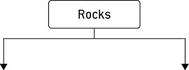

Student worksheet

2.3 Minerals are a valuable resource

Pages 22–23 and 161

Minerals as resources

1 What is an ore?

2 Australia is the world’s highest producer of which seven minerals and ores?

3 Why is the worldwide demand for resources increasing?

4 When and where was gold first discovered in Australia?

5 Why is gold almost always found as pure gold?

6 What is gold used for?

7 What are mineral sands? What do they contain?

8 What form is copper in when it is mined in Australia?

9 What is copper used for?

10 Which minerals are found in mobile phones?

11 Where are these minerals found?

12 What is a concern with mining these minerals?

Extend your understanding

Renewable and non-renewable resources are a big part of today’s society.

13 What is a renewable resource?

14 What is a non-renewable resource?

15 Are minerals renewable or non-renewable? Explain your answer.

16 What does this mean about our ability to mine minerals into the future?

17 What are two alternatives to mining new mineral resources out of the ground?

Student worksheet

2.4 Igneous rocks develop from magma and lava

Pages 24–25 and 162

Igneous rocks

1 What does the term ‘igneous’ mean?

2 What material is used to form an igneous rock?

3 What is the difference between lava and magma?

4 How does an extrusive igneous rock from? Give an example.

5 How does an intrusive igneous rock from? Give an example.

6 What is the most common type of rock in the Earth’s crust?

7 How are the following two types of this common rock formed and why do they look different to each other?

a Scoria

b Obsidian

8 Complete the following table to summarise the main differences between the formation of extrusive and intrusive igneous rock.

|  |  |  |
| --- | --- | --- |
|  | Extrusive Igneous Rock | Intrusive Igneous Rock |
| Formed by lava or magma? |  |  |
| Formed inside or outside of the volcano? |  |  |
| Method of cooling  (quick or slow)? |  |  |
| How does it reach the surface of the Earth? |  |  |

9 Label the following diagram of a volcano.

**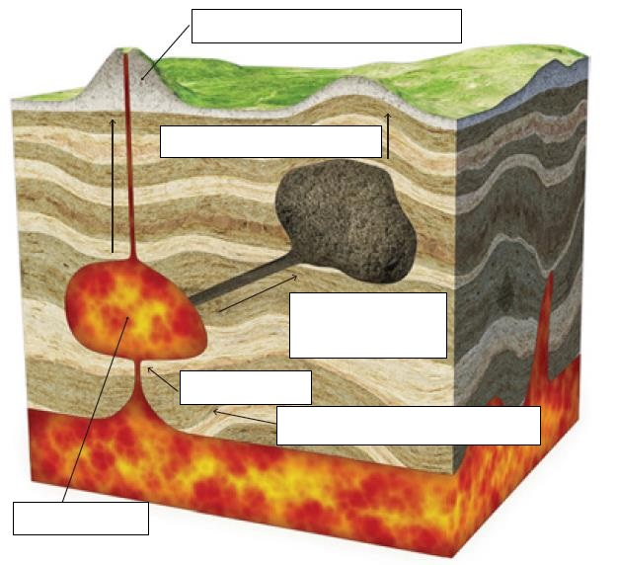**

Extend your understanding

10 Research igneous rocks, find five examples, and complete the following table.

|  |  |  |  |
| --- | --- | --- | --- |
| Name of Rock | Composition (what it is made of) | How it IS formed | function in the real world |
|  |  |  |  |
|  |  |  |  |
|  |  |  |  |
|  |  |  |  |
|  |  |  |  |

Student worksheet

2.5 Sedimentary rocks are compacted sediments

Pages 26–27 and 163

Sedimentary rocks

1 How are sedimentary rocks formed?

2 What are sediments? Give an example.

3 Where do the sediments that form sedimentary rocks come from?

4 Explain the process of the formation of sedimentary rock using the following diagrams.

|  |  |
| --- | --- |
| D:\OS8 worksheets and aw\jpgs ready for worksheets\SW0226_00951.jpg |  |
| D:\OS8 worksheets and aw\jpgs ready for worksheets\SW0227_00951.jpg |  |
| D:\OS8 worksheets and aw\jpgs ready for worksheets\SW0228_00951.jpg |  |
| D:\OS8 worksheets and aw\jpgs ready for worksheets\SW0229_00951.jpg |  |

5 What is an alternative method for the formation of sedimentary rock?

6 What is a fossil?

7 How is coal formed?

8 Give an example of a sediment made from biological material and explain how it is used in the real world.

Extend your understanding

9 Research sedimentary rocks, find five examples, and complete the following table.

|  |  |  |  |
| --- | --- | --- | --- |
| Name of Rock | Composition (what it is made of) | How it IS formed | function in the real world |
|  |  |  |  |
|  |  |  |  |
|  |  |  |  |
|  |  |  |  |
|  |  |  |  |

Student worksheet

2.6 Metamorphic rocks require heat and pressure

Pages 28–29 and 164

Metamorphic rocks

1 How are metamorphic rocks formed?

2 What does metamorphism mean?

3 Where does the extreme heat come from?

4 Where does the extreme pressure come from?

5 What happens when pressure is uneven? What effect does this cause?

6 What feature of rocks changes when they are subjected to heat and pressure? Give an example.

7 What are index minerals?

8 How is the rock gneiss formed?

9 What properties does a metamorphic rock have that is different from an igneous or sedimentary rock? Why?

Extend your understanding

10 Research the rock cycle and label the following diagram.

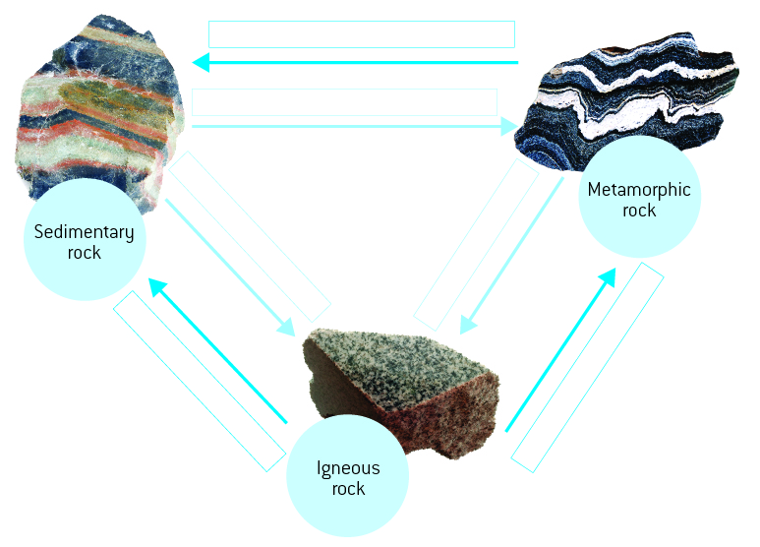

Student worksheet

2.7 The rock cycle causes rocks to be reformed

Pages 30–31 and 165

The rock cycle

1 What is weathering?

2 What is erosion?

3 How are physical weathering, chemical weathering and biological weathering different from one another?

4 What is onion-skin weathering?

5 Which environment does onion-skin weathering occur in?

6 What is frost shattering?

7 Which environment does frost shattering occur in?

8 What chemicals are usually responsible for chemical weathering?

9 What is responsible for biological weathering? Explain how this process occurs.

10 On Earth, where are temperatures greatest?

11 On Earth, where is pressure at its greatest?

Extend your understanding

12 In a cartoon strip, explain the journey of a rock from the Earth’s surface, into the Earth and out through a volcano. You must describe all of the changes that happen to the rock and why, as well as all transformations that the rock undergoes.

Student worksheet

2.8 Weathering and erosion can be prevented

Pages 32–33 and 166

Weathering and erosion

1 What is the role of a soil erosion engineer?

2 Why is there a need for this type of engineering?

3 What has happened to the population of Australia in the last 100 years?

4 What result has this had on Australia’s waterways?

5 Why is the removal of plants from waterways causing soil erosion?

6 What impact is soil erosion having on roads and building that are located near waterways?

7 Explain why the event in the following picture occurred.

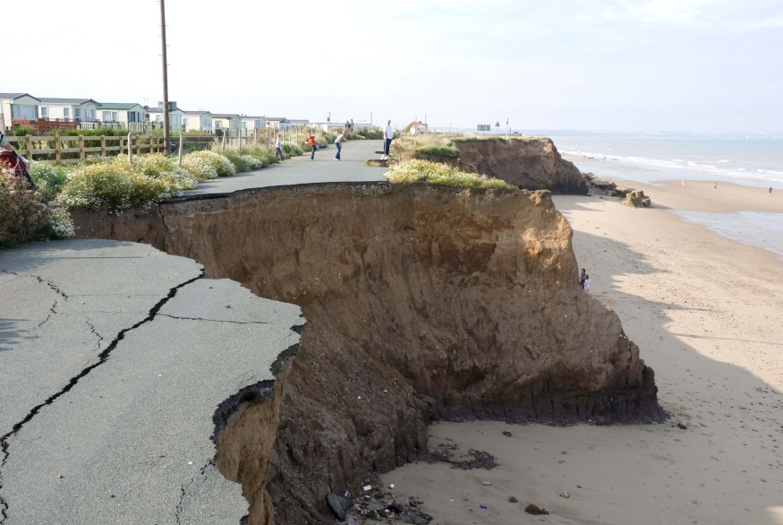

8 Match each of the following engineering solutions to the corresponding explanation of how it works to solve an erosion problem.

|  |  |  |
| --- | --- | --- |
| engineering solution |  | Explanation |
| 1 Control flow of water |  | A Avoids temperature erosion that results in cracks |
| 2 Terraces |  | B Prevents moss build up that results in biological or chemical erosion |
| 3 Grooves in cement |  | C Minimises the erosion of farms and river banks |
| 4 Holes in bricks |  | D Prevents erosion of beaches caused by waves |
| 5 Groynes |  | E Allows water to follow a set path that is protected from erosion by mad-made structures to minimise damage (e.g. drains) |
| 6 Regular cleaning |  | F Allows water to move into the soil rather than contributing to run-off |

Extend your understanding

9 Discuss the ways in which humans are responsible for

a weathering

b erosion

10 Outline two possible solutions for

a man-made weathering

b man-made erosion

Student worksheet

2.9 Rocks are studied by geologists

Pages 34–35 and 166–167

The work of geologists

1 How old is the Earth?

2 What is a fossil?

3 Use the following diagrams to explain the steps involved in the formation of a fossil.

|  |  |
| --- | --- |
|  |  |
|  |  |
|  |  |
|  |  |

4 What is comparative dating?

5 Why is this called ‘comparative’ dating?

6 Why is the oldest rock at the bottom and the youngest rock at the top?

7 What are index fossils?

8 What is radioactive dating?

9 Why are uranium and lead analysed in radioactive dating?

Extend your understanding

10 People who study geology at university perform many different roles in society. Research three geology occupations and explain what these people do in their careers.

a Occupation:

Explanation:

b Occupation:

Explanation:

c Occupation:

Explanation: